I would like you take everything I’m about to send to you in multiple messages and file links, plus your strong logic to pull all of this together.

I want to develop a Joomla 5 component and call it ACT (Advanced Content Types). It includes Advanced Content + Ecommerce + ERP Functions + other functions. This is a broad explanation of the component; I will be sharing many URL links, images, wireframes, and feedback I have had with other developers to try and get this component developed.

I need this Joomla Component to be able to manage a HUGE amount of content (I have identifies about 17 different types of content- example: an information article content type is simply a set of fields in a database and a layout that allows a person to see the data for that content type listing) without being heavy on queries and tables.

Think of this component as managing 10+ Million products across multiple product tables, and managing 100,000+ suppliers, and another 1 million blog article listings, etc. in admin: I use the content types, create fields, create layouts, import and capture information, create content lists, use Joomla menu to link to the content lists.

I think as you analysis all of my information, screenshots, etc. think you will see a lot of logical similarities with Odoo, erp next/ frappe, medusa and other similar systems.

I would like to use your advanced AI capability to develop this component along with free and open source premade function that could help you code better and pull this all together ☺. You can source from what you have access to and my information and other images to create a well construction Joomla Component.

**CONTENT =** this is any type of data that is stored and displayed.

It can be:

* a product listing
* or an informational article
* or information on a manufacturer
* or data on specific types of companies I want to market to sell product to

**Product Content Type example:**

I need to be able to create simple to complex products. Some products may have a lot of custom options- I need to be able to easily add these options (importing) or adjusting pricing.

I have documented a pricing field that is different to simply putting in a value. It works on being able to associate a sales price based on a % from other pricing field.

Example: Sales price is a locked % from a cost price. If I update the cost price it automatically updates the sales price.

In each CONTENT TYPE there are CONTENT PROFILES. This is done to keep content organized and used on the frontend in content lists or in the backend admin to access the content listings.

Before I build, import and manage content I have to create fields, categories and other structures to keep the content organized. I use the fields and create several layouts (admin view, frontend view, etc) using drag and drop and if necessary still being able to edit some layout code.

The core function of this component includes but not limited to:

* Clean and modern UI interface
* Load pages quickly
* I have a dedicated VPS but it also needs to install on a typical shared hosting environment (mySQL, etc)
* Expandable to build in additional future functions- example: perhaps helpdesk, chat, maybe AI features that auto create content or page listings, etc
* my version of content types (I will share additional information on this)
* custom frontend and admin layouts/ templates,
* full ecommerce that integrates directly with the ACT component’s accounting and financial functions- meaning, a sale is recorded into the ERP relation functions
* multiple ERP related functions- such as HR (Human resources to manage employees, payroll, employee data, full tax related process and documents for sales tax, income company tax, etc) ,
* inventory,
* managing multiple companies (example: a business structure of a parent Company with subsidiary companies underneath the parent company) and various company locations,
* CRM (Customer relationship manager),
* the ability to view multiple product related listings as part of a manufacturing process in a product listing so I can see what parts are used to make the product and my total production cost for the product
* I also need to be able to create connections between any content types- example: I have a manufacturer brand listing in a table, then in another table I have a core product listing that that company makes. Being able to associate these 2 separate listings together.
* There is also a concept of centralized and decentralized data/ information- this is essentially when I create information (across the various content types) and then I can share the content with another company who would have a version of this component in their own Joomla website- more about this later on.
* Content Lists- I setup rules that identify what content listings should be displayed in the ‘content list’
* I need the admin UI to be clean, modern and easy to navigate (similar to <https://themesbrand.com/velzon/html/master/dashboard-crm.html>)
* Ability to create email marketing emails using a visual designer (perhaps a blend of <https://app.grapesjs.com/studio/email?utm_source=grapesjs&utm_medium=mainTopNav> and <https://demo.vvveb.com/admin/?module=/editor/editor&template=index.html&url=/>)

When I say that the Joomla Component is like a ‘blank slate’ I mean it is very flexible in allowing me to create any type of content. The essence of this component resides in its flexibility to create content types with custom fields, then to take these fields and create multiple layouts, then create a listing that loads the template so I have a stylish UI to capture the data. I can then create a content list (based on a series of display rules) to display the listings that match the display criteria, this can be for the Joomla admin view or for the frontend. I use a menu structure (admin and frontend) to display the content list.

Below is additional information and consideration thoughts on broad and specific functional processes that can be used with my explanation of images and wireframes and other feedback.

**Fields**

Creating a variety of custom fields will be essential. These fields will be used across various screen layouts to record information (i.e. admin edit screen, frontend detail page, etc).

Each content type will require a default list of hard coded field- similar to a Joomla article. Such as title, published/ enabled, etc

However, a product content type will have additional hard coded fields that other content type (such as an article) would not have.

**My Company Structure**

My company is setup as a Parent company (called Vornburgh) with subsidiary companies (example: Waslix, Hale, etc)

Accounting, finances from the individual subsidiaries are consolidated into the 1 parent company (helpful for annual taxes, and other financial considerations) while still being able to record and view accounting and financials for each company individually. I need to be able to manage separate inventory for each company

I need to be able to manage each company through this component if necessary- meaning, create company structures with individual employees, locations, departments, etc

I need to be able to create custom fields and then display these fields though a visual layout builder

**CONTENT TYPES:**

Some CONTENT has multiple PROFILES with 1 database table while others have individual database tables. Each database table type has their own fields, templates, etc. The reason for this, has to do with the similarities of required fields.

Each database table ‘type’ has its own field manager, template structure *(for frontend and admin*). Please note that when I create a content list I can pull listing for multiple content type database tables into one view/ content list *(this will mainly be done to display content on the frontend).*

some content will be products, visible on the frontend for sale; other content types will be used to record information and really only applicable to admin access; while other content types will behave very much like an article to display information about a topic. I will be able to connect any content type together and control if the connection will be visible on the frontend for each listing.

A user profile is the typical user access profile to login to the site. Site Admins will be able to link a user profile to specific content-profile listings where and when necessary.

Example:   
Water pump products will have a lot of fields that do not relate to water filtration products, an ozone water filtration product group will have a larger concentration of fields that relate specifically to the equipment that has nothing to do with parts, etc. So, instead of creating 1 database table for each CONTENT, I think it will be better to use multiple databases tables.

|  |  |  |  |  |  |  |  |  |
| --- | --- | --- | --- | --- | --- | --- | --- | --- |
| **CONTENT Type** | **Profile** | | **Type** | | | info | Table name example | |
| Products  **pro** | Core  **1** | | *Example:* Water Treatment **1** | | | Database table | fig3u_jerp_ct_**1**_pro_**1**_1_cf | |
| *Example:* Water Pump **2** | | | Database table | fig3u_jerp_ct_**1**_pro_**1**_2_cf | |
| *Example:* Solar **3** | | | Database table | fig3u_jerp_ct_**1**_pro_**1**_3_cf | |
| *Example:* Air Filtration **4** | | | Database table | fig3u_jerp_ct_**1**_pro_**1**_4_cf | |
| *Example: Water Heater* **5** | | | Database Table | fig3u_jerp_ct_**1**_pro_**1**_5_cf | |
| Replacement  **2** | | *Example:* UV related **1** | | | Database table | fig3u_jerp_ct_**1**_pro_**2**_1_cf | |
| *Example:* Water Filtration **2** | | | Database table | fig3u_jerp_ct_**1**_pro_**2**_2_cf | |
| Parts  **3** | | Typical **1** | | | Database table | fig3u_jerp_ct_**1**_pro_**3**_1_cf | |
| Advanced **2** | | | Database table | fig3u_jerp_ct_**1**_pro_**3**_2_cf | |
| Specialized **3** | | | Database table | fig3u_jerp_ct_**1**_pro_**3**_3_cf | |
| Digital  **4** | | Digital **1** | | | Database table  Example- software, file, etc purchase and then get access to download | fig3u_jerp_ct_**1**_pro_**4**_1_cf | |
| Produce | | I plan on selling my own custom built water filters. I’m not too sure from a coding point of view if an additional database is required as this is more about connecting different product listings together when create a product listing in “Core”. Essentially it is like the connection builder so I can see the individual costs of the parts used so I can establish selling prices and how to build the product when it is ordered. I will show you visually at later… | | | | | |
| Group | | *I do not think a separate database is necessary- probably better to use the listing connection function.* Groups 2 or more products together- each products can be purchased individually while adjusting quantity | | | | | |
|  |  | |  | | | | | |
| **CONTENT Type** | | **Profile** | |  | info | | | Table name | |
| Production  **prodt** | | Companies **1** | | Database table | Mainly for manufacturers, and product brands related to an actual product | | | fig3u_jerp_ct_**1**_prodt_1_cf | |
| I will use a custom field to identify: Parent, Subsidiary, Brand | |
| Channel  **chan** | | Distributor **1** | | Database table | This is for companies who are related to manufacturers and brands who are involved in marketing and selling a product | | | fig3u_jerp_ct_**1**_chan_1_cf | |
| Supplier **2** | | Database table | fig3u_jerp_ct_**1**_chan_2_cf | |
| Dealer **3** | | Database table | fig3u_jerp_ct_**1**_chan_3_cf | |
| Reseller **4** | | Database table | fig3u_jerp_ct_**1**_chan_4_cf | |
| Contacts  **con** | | People **1** | | Database table | A contact for any content type- mainly “Production”, “Channel”, “Vendor”. These would be people who work for a company. | | | fig3u_jerp_ct_**1**_con_1_cf | |
| Location  **loc** | | Location **1** | | Database table | A location for any content type- mainly “Production”, “Channel”, “Vendor” | | | fig3u_jerp_ct_**1**_loc_1_cf | |
| Vendor  **ven** | | Vendor **1** | | Database table | These are companies who I would purchase something from but not products that I intend to sell. Example: I purchase something from Amazon.com , or I buy office furniture from Walmart, or paying my electricity bill. | | | fig3u_jerp_ct_**1**_ven_1_cf | |
| Internal  **int** | | Resource **1** | | Database table | This is anything internal that I may want to store data on- example a link to a water quality database, or an idea on something…  I can also use this to capture ideas about a potential target markets- I create a new profile called “Target Profile” with it’s own database table, etc | | | fig3u_jerp_ct_**1**_int_1_cf | |
| Another Resource **2** | | Database table | fig3u_jerp_ct_**1**_int_2_cf | |
| Activity  **activ** | | Task **1** | | Database table | Similar to a type of CRM function where I can tract tasks or assigning a task to an staff member. It is more of a mini workflow | | | fig3u_jerp_ct_**1**_act_1_cf | |
| Workflow **2** | | Database table | A workflow is an advanced task that will have a lot of effort and time to complete. Similar to a CRM design but called CWF (Content Work Flow) | | | fig3u_jerp_ct_**1**_act_2_cf | |
| Project **3** | | Database table | I create a new profile through the admin and it generates its own database table, etc | | | fig3u_jerp_ct_**1**_act_2_cf | |
| Information  **info** | | Article **1** | | Database table | Like a regular CMS article | | | fig3u_jerp_ct_**1**_info_1_cf | |
| Blog **2** | | Database table | Like a blogging function- informal article style | | | fig3u_jerp_ct_**1**_info_2_cf | |
| Webinar **3** | | Database table | Similar to an article but focused on a video content | | | fig3u_jerp_ct_**1**_info_3_cf | |
| Technology **4** | | Database table | info on different technologies instead of using a custom field to isolate the article type. | | | fig3u_jerp_ct_**1**_info_4_cf | |
| Contaminants **5** | | Database table | I create a profile to store information on several water Contaminants | | | fig3u_jerp_ct_**1**_info_5_cf | |
| Filtration Media **6** | | Database table |  | | | fig3u_jerp_ct_**1**_info_1_cf | |
| Equipment **7** | | Database table |  | | | fig3u_jerp_ct_**1**_info_7_cf | |
| Markets  **mark** | | Industry **1** | | Database table | This could be used to partner with (example) a home builder- I create a listing with custom fields to capture their company info, model home info and then link individual products to their model home that can be purchased, etc | | | fig3u_jerp_ct_**1**_mark_1_cf | |
| Division **2** | | fig3u_jerp_ct_**1**_mark_2_cf | |
| Group **3** | | fig3u_jerp_ct_**1**_mark_3_cf | |
| Locations **4** | | fig3u_jerp_ct_**1**_mark_4_cf | |
| Companies  **comp** | | Home Builder **1** | | Database table | I will use this to import a list of companies to try to market to. | | | fig3u_jerp_ct_**1**_comp_1_cf | |
| Restaurant **2** | | Database table | fig3u_jerp_ct_**1**_comp_2_cf | |
| Plumber **3** | | Database table | fig3u_jerp_ct_**1**_comp_3_cf | |
| Installer  **inst** | | Company **1** | | Database table | These would be companies or people I’m promoting who would actually be able to install products. I would realistically also link them to the locator map function. | | | fig3u_jerp_ct_**1**_inst_1_cf | |
| Group **2** | | Database table | fig3u_jerp_ct_**1**_inst_2_cf | |
| Team **3** | | Database table | fig3u_jerp_ct_**1**_inst_3_cf | |
| Person **4** | | Database table | fig3u_jerp_ct_**1**_inst_4_cf | |
| Affiliate  **aff** | | Affiliates **1** | | Database table | These would be people or companies I’m partnering with who promote an individual product or every product. I would need to keep track of who they are… | | | fig3u_jerp_ct_**1**_aff_1_cf | |
| I will use a custom field to identify: Blogger, Influencer, Promoter, Company | |
| External  **ext** | | Buyer | | Database table | I may need to allow certain user profile to capture additional information about themselves- like address, etc. I link the user account to their buyer profile. This way the use account is just kept for essential login data. | | | fig3u_jerp_ct_**1**_ext_1_cf | |
| Entry  **ent** | | Endorsement **1** | | Database table | This is like a client feedback function | | | fig3u_jerp_ct_**1**_ent_1_cf | |
| I will use a custom field to identify: Case Study. Testimonial | |
| Marketing  **mrking** | | Advertiser **1** | | Database table |  | | | fig3u_jerp_ct_**1**_mrking_1_cf | |
| Advert **2** | | Database table | fig3u_jerp_ct_**1**_mrking_2_cf | |
| Marketing **3** | | Database table | fig3u_jerp_ct_**1**_mrking_3_cf | |
| Social **4** | | Database table | fig3u_jerp_ct_**1**_mrking_4_cf | |
| Form  **form** | | Form **1** | | Database table | A contact form function. | | | fig3u_jerp_ct_**1**_form_1_cf | |
| Form **2** | | Database table | fig3u_jerp_ct_**1**_form_2_cf | |
| Form **3** | | Database table | fig3u_jerp_ct_**1**_form_3_cf | |
| Form **4** | | Database table | fig3u_jerp_ct_**1**_form_4_cf | |
| User  **user** | | User **1** | | Database table | Not really a content type.  A database storage system to allow users to login  There are user access accounts- username, password, email- basic info. I can link a content type to a user. | | | fig3u_jerp_ct_**1**_user_1_cf | |

**The Product Content Type:**

The Product content type is different to the other content types because it relates to creating products in different tables, connect to the ecommerce function, integrating into erp functions like finances, accounting, etc

|  |  |  |  |  |
| --- | --- | --- | --- | --- |
| **CONTENT Type** | **Profile** | **Type** | info | Table name example |
| Products  **pro** | Core  **1** | *Example:* Water Treatment **1** | Database table | fig3u_jerp_ct_**1**_pro_**1**_1_cf |
| *Example:* Water Pump **2** | Database table | fig3u_jerp_ct_**1**_pro_**1**_2_cf |
| *Example:* Solar **3** | Database table | fig3u_jerp_ct_**1**_pro_**1**_3_cf |
| *Example:* Air Filtration **4** | Database table | fig3u_jerp_ct_**1**_pro_**1**_4_cf |
| *Example: Water Heater* **5** | Database Table | fig3u_jerp_ct_**1**_pro_**1**_5_cf |
| Replacement  **2** | *Example:* UV related **1** | Database table | fig3u_jerp_ct_**1**_pro_**2**_1_cf |
| *Example:* Water Filtration **2** | Database table | fig3u_jerp_ct_**1**_pro_**2**_2_cf |
| Parts  **3** | Typical **1** | Database table | fig3u_jerp_ct_**1**_pro_**3**_1_cf |
| Advanced **2** | Database table | fig3u_jerp_ct_**1**_pro_**3**_2_cf |
| Specialized **3** | Database table | fig3u_jerp_ct_**1**_pro_**3**_3_cf |
| Digital  **4** | Digital **1** | Database table  Example- software, file, etc purchase and then get access to download | fig3u_jerp_ct_**1**_pro_**4**_1_cf |
| Produce | I plan on selling my own custom built water filters. I’m not too sure from a coding point of view if an additional database is required as this is more about connecting different product listings together when create a product listing in “Core”. Essentially it is like the connection builder so I can see the individual costs of the parts used so I can establish selling prices and how to build the product when it is ordered. I will show you visually at later… | | |
| Group | *I do not think a separate database is necessary- probably better to use the listing connection function.* Groups 2 or more products together- each products can be purchased individually while adjusting quantity | | |

**Teams Feedback chat with my human developer:**

|  |
| --- |
| regarding the price of a custom field:  Hard coded fields means- The fixed fields inside the code, (Like title alias sku price etc.) These fields are the base for the content type. What's happening is , when we create a new category ( 3 tables have been created automatically, and based on the code the har coded fields data has been filled inside the customfield table having flag is_hard. simultaenously (based on hard coded fields ) the columns have been created inside the product table (like if there are 10 hard fields, 10 columns have been created.)    The breakage is only due to the different table structures.    We can avoid that as well    By creating a script or some plugin to update the existing categories table    Like if in future (Let's say i have the hard code field  intro which is  of type act_textarea, but we need to change its type inside the code part (to act_text), then we need to create a sepeate script or plugin methods to update the changes in the existing categories as well    I think this is the only way to synchronize the changes    Pierre Jordaan  6/24/2025 10:10 AM  I think having a script that can update the necessary parts/ tables will be vital because I can completely see the need to add in extra hard coded fields that have been missed/ not considered. Glad there is a work around logic to account for these hard coded fields.  Yes, we will create a script, so if any modification is table structure would be there, then we ran the script as well to maintain the uniformity  The fist potential issue with hard coded fields and adding additional fields may be the issue of pricing structures for different users (example: pricing for non registered users, another pricing for resellers, a different price for buyer level 1 - for example, etc)    Not too sure if this should be hard coded or a separate table. My though is that if it is part of the same listing table it may make it easier to maintain instead of mapping ID number to another separate table for the product content type.    This will ONLY happen for the Product Content Type (the other content types are not related to products 🙂)  FYI: just sharing my thoughts on the pricing levels...    Other ecommerce functions like VirtueMart (uses "Shopper Groups"), Phoca Cart (uses "Customer Groups") to control displayed pricing. You can go into each product listing and establish a pricing for a group. The user is then linked to a group and when the user logs in they see a different price. I know you know this logic 😃    The only potential problem is that this logic would surely use a different database table to hold the data. If I have 1 million products and perhaps 4 different pricing relationships that is 4 million entries in 1 table that will need to be retrieved- not efficient.    With these systems (VirtueMart, Phoco cart) you apply 1 or more shopping groups to their individual user profile (to control what pricing the user profile can see). In the product listing you create a new pricing level and state what shopper group it applies to.    **I wonder if all of this can be simplified with User Access Rights and incorporating Pricing Percentages?**  Meaning: in a product listing, I create a pricing level for a user access right and can base the pricing on a percentage. I enter the percentage or new $ price (auto calculates the %). This way when I update the original price it will auto calculate the user profile price (this way I do not need to run multiple ways to update all the pricing levels)  **perhaps it is better to have individual 'SalePrice' fields for each levels (perhaps hard code 10 Sale Price fields- 1 for each user level up to 10 possible user levels)**    In each 'saleprice' field configuration (SalePrice1, SalePrice2, etc) I would identify which user has access to this pricing field.  I could still use a % to auto calculate the user price (like the weight and dimension function that auto calculates). This logic would also help with making pricing updates (meaning, update cost or retail price fields and since all other SalesPrice fields are auto calculated from an identified %, I will not need to updates the SalePrice fields.      One more query, for each product in the same listing , they may have different price as well? Like for plumber  product1 is at discount 10percent and for product2 it's 15 percent??    Or it would be same for the all products in listing just like setting things in configuration of the field?    **Sanidhya totla**  One more query, for each product in the same listing , they may have different price as well? Like for plumber product1 is at discount 10percent and for product2 it's 15 percent??  correct. each product will have a different % or $    Ok i will create a new custom field called price which is used for entering the value of cost price and retail price, it would be a normal number type field. Having the option to select currency as well. Now I will create a new custom field with a name dynamic price which has some configuration, on listing side the price field is just normal as number field and fir dynamic field, we have subform kind of thing for each group like we select the group registered we will get the options like adding  existing field plus logical operators a well,    So if there are 20 groups in product listing if I add dynamic price for only 1 group then other groups have default values    Does it make sense, Am I in line with requirements and your thoughts    Yes, this sound like a strong logical process that can avoid relying on another table to control pricing differences.    Yes, it will surely avoid the new table creation    And, as per my thinking it will fulfill our requirements. But we need to fill pricing formulas  for each and every product    **Sanidhya totla**  And, as per my thinking it will fulfill our requirements. But we need to fill pricing formulas for each and every product  While creating product    In the beginning I will just have 1 sales price (guest or registered user) but later on I need to partner with other companies (like plumbers) to help sell more water filters to their clients. When that happens I can go in and create a different price for a plumber. I do not nee to establish all pricing levels in the beginning for every product listing (I do however need to have this be a functional part from the beginning)    Ok understood.    **Sanidhya totla**  Ok i will create a new custom field called price which is used for entering the value of cost price and retail price, it would be a normal number type field. Having the option to select currency as well…  Let's go with this logic    **Pierre Jordaan**  In the beginning I will just have 1 sales price (guest or registered user) but later on I need to partner with other companies (like plumbers) to help sell more water filters to their clients. When that…  But I am afraid of one thing, for establishing relation with plumber , we need to edit sales prices for all products .    Or one thing I can do is , in configuration of custom field dynamic price we will add the pricing logic there as well, so globally they can be utilized in absence of pricing logic in product    Could we have a 'rule' or something like that says if a separate pricing is not identified for the user group then it defaults to the guest or registered user pricing level? |

**Content Lists**

A Content list will be used to show listings from 1 or multiple content sources that meet specific criteria. These content Lists can be displayed in the admin or frontend screen.

I setup the criteria or rules that determine if a content listing should be included in the list. A lot of this logic comes from the Joomla Community Builder component (https://www.joomlapolis.com/ ) I used it on my core site: <https://waslix.com/water-treatment-and-filtration/hard-water-treatment/impulse-frequency>

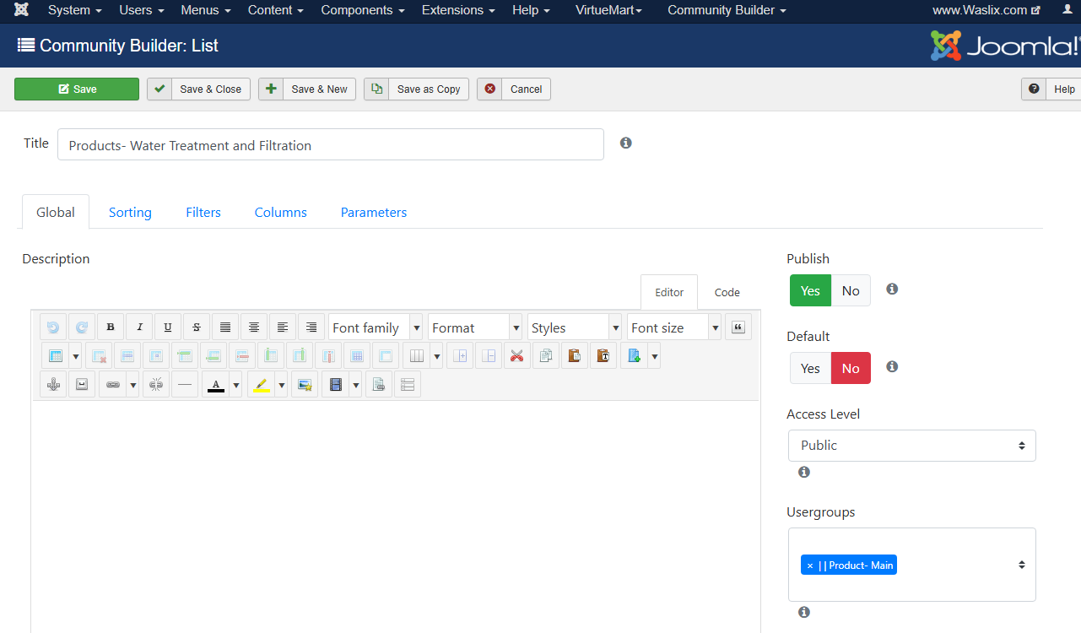

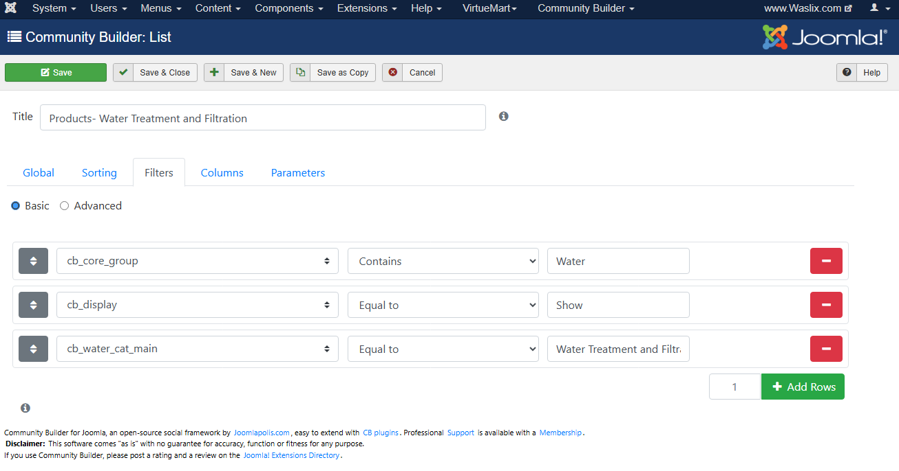

**Admin UI:**

I have source code for:   
  
Design style: <https://themesbrand.com/velzon/html/master/dashboard-crm.html>

PHP Documentation: <https://themesbrand.com/velzon/docs/php/index.html>

Bootstrap documentation: <https://themesbrand.com/velzon/docs/html/index.html>

I have source code for:   
<https://mdbootstrap.com/docs/standard/getting-started/installation/>

I would like the admin UI to be clean and easy to navigate.

The flexibility of creating menu links in the Amin, i.e. menu links to an individual content list

**Visual Designer Layouts:**

I like the clean UI of a visual drag and drop style <https://demo.vvveb.com/admin/?module=/editor/editor&template=index.html&url=/> it resembles <https://grapesjs.com/demo.html> but improved upon.

Source:

<https://www.vvveb.com/>

<https://grapesjs.com/>

I would like to incorporate a flexible visual builder for:

* creating content type layout screens (Admin: listing entry, quick view) and (Frontend: entry)
* creating content lists
* used in some of the advanced field types

I have also created mockup screenshots that will be shared with you later on…

I would there to be 3 distinctive areas in the “Layout Editor” (like vvveb.com)

Left: these are the building elements

Center: The canvas

Right: When you click an item you can style it, additional options

**Dashboard:**

I create a dashboard layout for a content type.

Example: a manufacture- I create a dashboard displaying connected product content types, connected employees, sales associated to this company from product sales, etc

**Connection Manager (very important function)**

I need to be able to connect different CONTENT TYPES together. With some listings, I will show the connections on the frontend and with other listings, I will hide the connections on the frontend.

Example: A Product Content Type Listing may display the connected manufacturer, but hide who the supplier is. It may show other associated products (such as purchasable parts) or I may want to connect a ‘blog’ style content type to the main product listing and connect a technology article to the product listing.

**Datasets:**

This relates to me taking content and sharing or selling it to another company. I want to build the content on my website and then when I’m ready create a content dataset that another company can import into their version of the Joomla Component. When another company imports the file or it automatically feeds into their system (subscription plan) it automatically install the fiddles, structures etc WITHOUT having to install multiple .xls or .csv files of exported data from my site.

This is NOT like exporting a manufacturers products to an csv file and then importing. A dataset is perhaps like an API *(or another technical wording that I do not know about).* It means I can create a file with whatever I want (custom fields, categories, content type products listings from a specific manufacture, an combination of elements, etc)

The concept of a dataset is that I create this dataset file and another company can take the dataset and import it into their version of this CMS and have the structure I created without any import/ export errors.

Practical example:   
I share a simplified version of the CMS with a partner dealer. I then create a dataset for a manufacture who they also represent. They either get the dataset from me and manually import OR I make a connection between my CMS and their CMS so their CMS can automatically download and import where there is an updated dataset version.

Take a look at the screenshots and wireframes of my centralized and decentralized images.

**Ecommerce:**

So, when a sales is made through the frontend or an sale is manually entered in admin it automatically goes into the ERP accounting system.

I do not like the logic of Joomla Virtuemart (https://virtuemart.net/) or Phoca cart (<https://www.phoca.cz/phocacart>) as these function cannot effectively manage the demands of trying to manage 10+ million product listings.

The component will also have an ecommerce function to allow product content types to be purchased. When a sale is made through a shopping cart, the ERP generates an order that can be tracked. Example: if the products need to be purchased from a supplier, or taken from inventory. The entire order filament lifecycle can be managed and recorded. As a sale is being recorded, it impacts financial and accounting considerations. Example: a sale is made- the cost of the sale is recorded along with income (typical accounting processes).

In the past I have looked at <https://frappe.io/>, <https://frappe.io/erpnext>, <https://frappecloud.com/marketplace/apps/ecommerce_integrations> but the frappe system is not conducive to php. When I tested a basic installation I found several logic issues that would not work when what I’m trying to build. Example: The frappe system loads suppliers and products from inside a dropdown sector field. Since I’m trying to build a function that can manage millions of products and a huge amount of suppliers I cannot load this into a dropdown (it will crash the system). Using this as an example, I need to be able to open another screen to bring in a supplier, products, etc. (content type) into a manual invoice, or creating a purchase order. My idea would be to load a paging list of suppliers, brands, products, etc. Then use the listing filter feature to find the right listing and then insert into whatever I’m process- like a manual order, or a purchase order, etc

There are other logical issues I have found with Joomla Virtuemart and Phoca cart, example: See my feedback on managing file logic. These other systems have only 1 folder to store product images. This will be impossible to manage when you have potentially millions of products listings!

I have also looked at <https://medusajs.com/> (I know this is not php based - https://docs.medusajs.com/). I was very impressed with what I saw with Medusa Js UI and function (originally trying to develop a custom CMS system that incorporated the prebuilt Medusa Js and keystonejs.com as a premade starting point but human developers said it was too complicated. I abandoned this idea and went back to Joomla. Perhaps later in 2026 or 2027 when I have an advanced, mature and stable version of this Joomla component we can look at converting it over to newer tech like js based)

I DO NOT know what ecommerce function to give to you as an example.   
Is it sensible for you to use certain components from Medusa Js Ecommerce/ framework into this project and convert them over to php while being able to make all of what I’m expressing integrated as 1 component? <https://medusajs.com/v2-overview/> and <https://docs.medusajs.com/>

A significant consideration with an ecommerce function is the ability to create custom options for a product. A few years ago, I was considering having a few VirtueMart plugin developed to help me have a flexible way to create product options. I have included my thoughts and logic under the “4 eCommerce” folder. The relevant folders start with “VM-“. Perhaps you can analyze this, then and take a sense of this while considering the screenshots (in the other folders I’ve shared with you) and developer a strong and logical way to manage a Product Content Type attributes/ options.

I think my screenshot (located in :4 eCommerce\Product Options\Customization Options.jpg”) is a good holistic representation of the Product Content type options and being able to add options/ attributes to product listings. Just remember- product listings are spread out across multiple tables and I think it is sensible to assume a product options/ attributes will be grouped together with the logic of separate tables- meaning a water filtration core product types will have options specific to that content type.

**Wish list:**

Typical function but users can create wish list groups- this is a typical function. I can also find a user and manually connect or remove product for them.

**Financials:**

Income and expenses will be recorded into yearly financial reports so as to pay government income taxes, sale taxes, view the finances of the company, etc.

**Importing and exporting:**

I need an east to use, and visual way of importing data throughout this CMS. Example import an excel file and then associate the columns with specific fields. Save the structure for future importing tasks.

Example: <https://www.ukrsolution.com/Joomla/Import-Users-To-CommunityBuilder-Joomla-From-Excel-CSV-File>

Also look at my screenshots

**Bulk changes:**

I need to be able to make bulk changes for content type listings. I can create a filter to identify certain listings and then made the changes.

Example:

product content type listing- updating pricing,

OR blog article content type- I need to reassign a lot of listings to a new category,

OR with a product content type for a specific manufacture – I get the URL for each product image and it goes to the page, saves the image and displays the image in the image field, etc

**CRM** = content work flow (CWF) but with the functionality of a CRM. CRM stands for Custom Relationship Manager- this is not really applicable because it relates specifically to “Customers/ Clients” whereas the **CWF (Content Work Flow)** can be connected to any CONTENT listing. I would check a button in the listing (CWF) and the listing could then be easily grouped together. I will show a visual but it is essentially like using the idea of Content List, Custom Menu link and the general idea of a typical CRM management.

Example: I can take any content type and mark it for CRM tracking. I can create my own fields, structures, organized lists, etc

Some products will have consumable and compatible products but these can be linked together through the ‘connection’ function. Meaning, I link content listings together by establishing an associated link using the connection function.

Example:   
A UV system:   
This has the main product and it has replacement UV bulbs, power converters and also other competitor’s UV bulbs that can be used instead of the branded UV Blub.

**File Manager:**

Take a look at the visual images

Source:

<https://www.bootdey.com/snippets/view/Drive-files-documents-user-profile>

<https://uppy.io/>

A lot of this relates to accessing files (documents, images, etc) inside a listing. When I’m in a content listings it opens directly to the folder path.

**Google merchant and other online marketplaces**

Be able to identify a product listing to be includes in a marketplace XML file so that the online marketplace (google merchant, bing shopping, ebay, amazon, etc) can retrieve product information without me having to manually export data and manually upload.

**Finances**

I would like to be able to identify where income sources are originating- manual entry, ecommerce, marketplaces, etc. I plan on listing products for sale on market places such as: google merchant, amazon, Facebook, desert cart and many others.